A000-EUR-Vinca-figurine-male with trousers-terra cotta 5700-4500 BCE

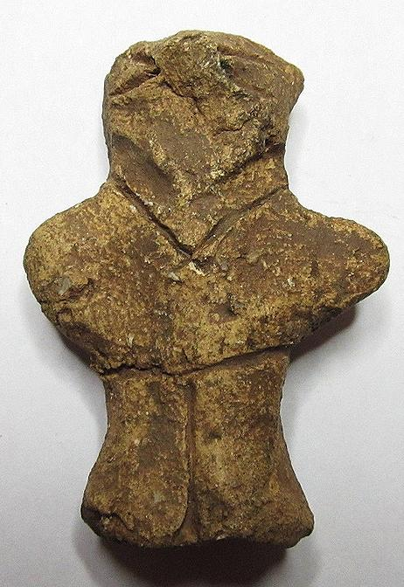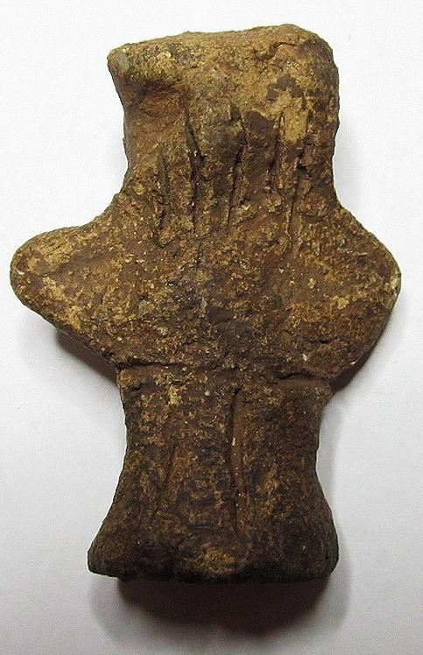 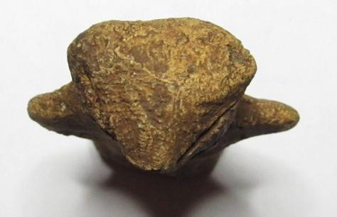

Case No.: 3

Formal Label: Vinca Neolithic ceramic male figurine with trousers, ca. 4500 BCE-13.5 cm

Accession Number:

Date or Time Horizon: ca. 4500 BCE

Geographical Area: Balkans

Cultural Affiliation: Vinca

Medium: Fired clay

Dimensions: H 13.5 cm

Weight:

Condition: Excellent

Provenance: Michael Davies 2 hanover court Didcot Oxfordshire ox11 8nu United Kingdom

**References:**

**Discussion:**

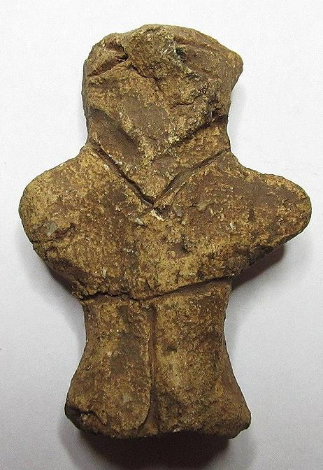 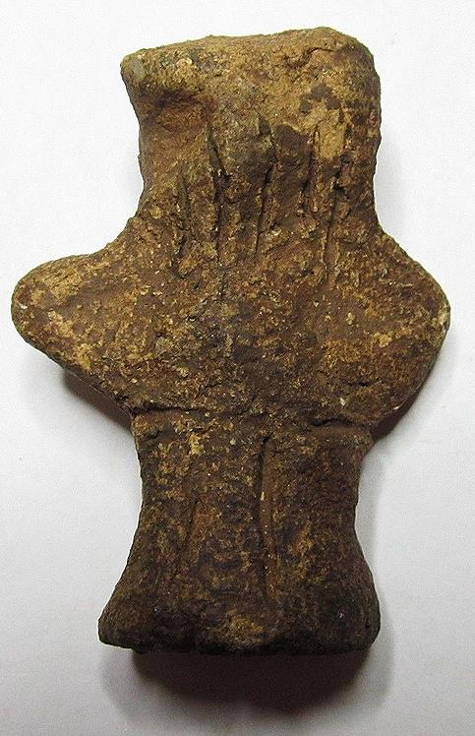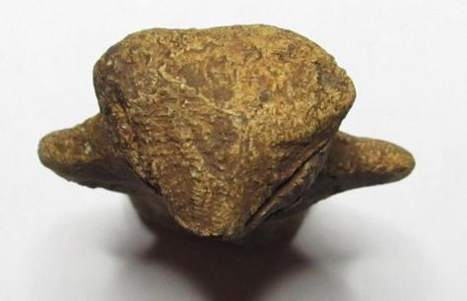

#### [Ancient Neolithic Vinca Culture Idol Goddess ~ old collection!](http://www.ebay.com/itm/281906133218)

|  |  |
| --- | --- |
| Item price | $330.00 |
| Quantity | 1 |
| Item number | 281906133218 |
| Shipping service | Standard Shipping from outside US |

Ralph J Coffman Jr

149 Atlantic Ave

Swampscott MA 01907-2427

United States

## Order total

|  |  |
| --- | --- |
| Subtotal | $782.50 |
| Shipping | $32.99 |

**Total**

$815.49

Order placed on

Monday, Jan 18, 2016

Payment method

PayPal

Payment date

Monday, Jan 18, 2016